Operating Systems

“Mini Project 😊”

Memory Allocation

Names: Eslam Alaa Zaki &  
 Eslam Medhat Mahrous

Section : 1

How the program works:

1. Choose the size of Memory.
2. State the size of a hole and its starting address then hit “add hole”.
3. Repeat step 2 as desired.
4. After finishing adding the holes click “done”.
5. You can now allocate or deallocate any process you want.
6. To deallocate any process just double click on its row -as simple as that 😉-.
7. To allocate a process choose the desired Methodology.
8. Then choose the size of the process and click ”allocate process”.
9. Any status will appear into a status box

Here is a test case for demonstration :

1. This is the initial shape of the program 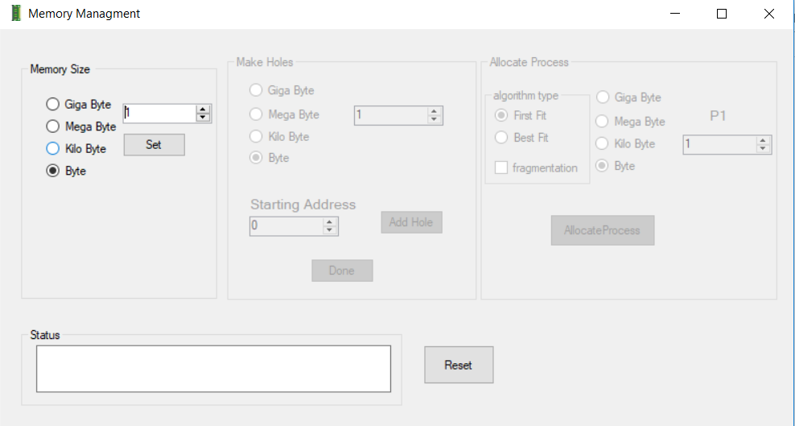
2. Set the size of memory to 1 kilobyte 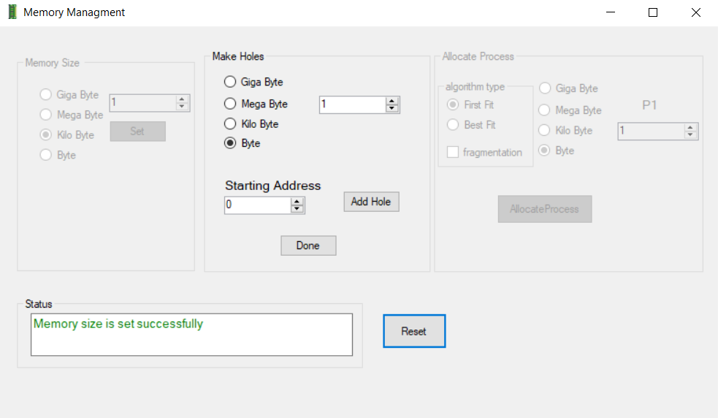
3. Adding holes

Size starting address

1. 10 25
2. 40 50
3. 10 100
4. 100 150
5. 200 500
6. 15 5
7. 200 1000 out of memory:ex check error

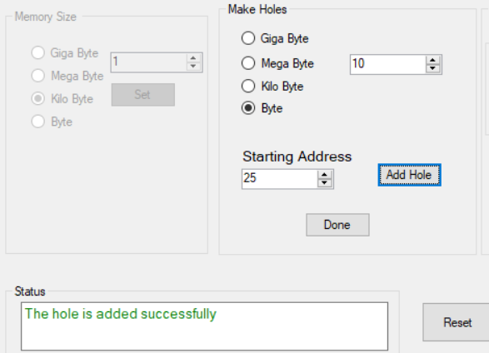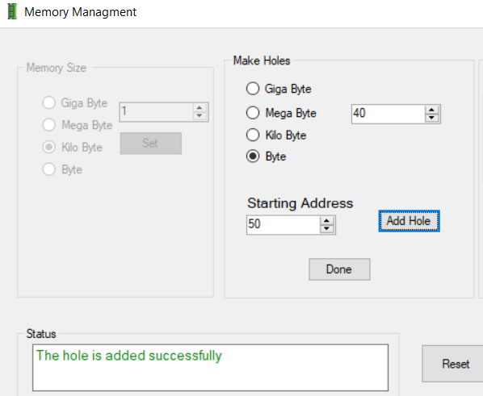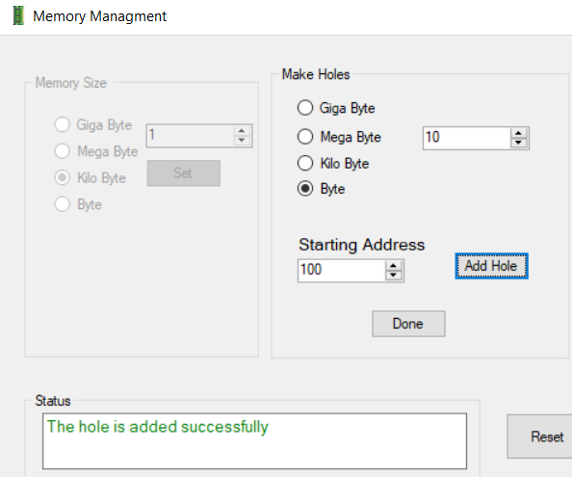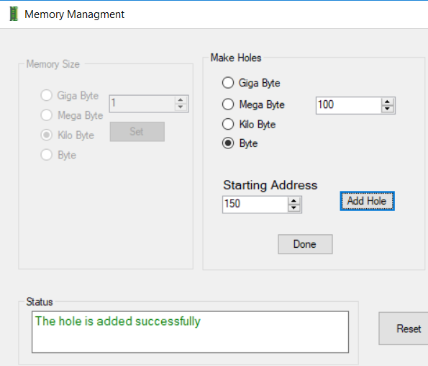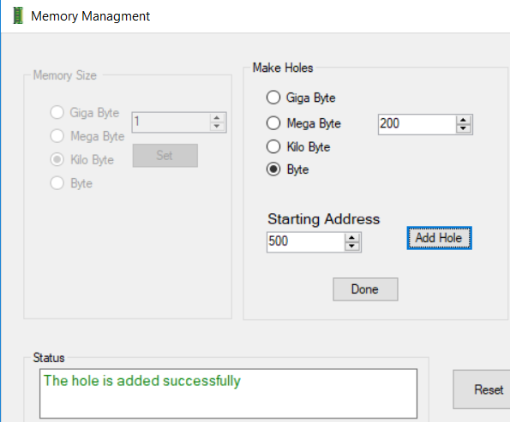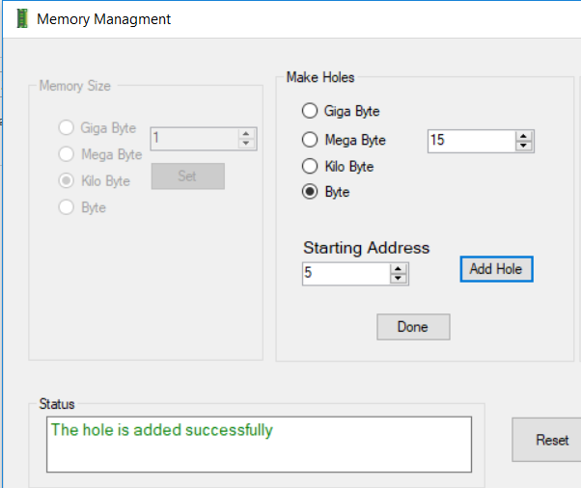

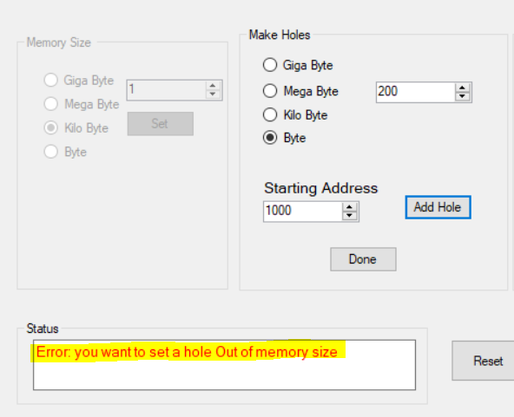

1. After Clicking Done the shape of the memory will be

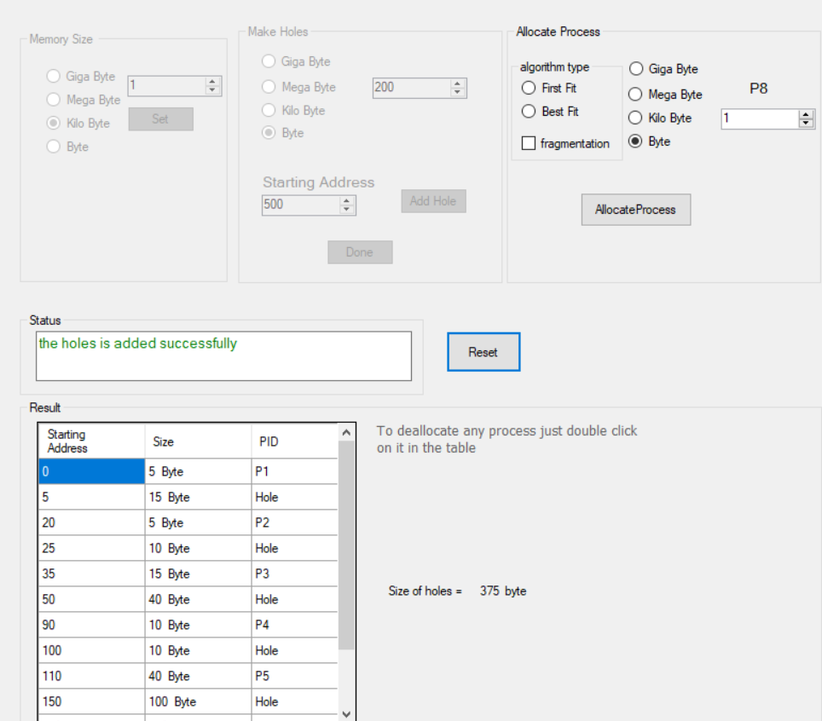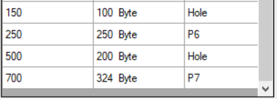

1. Allocate process P8 with size 1byte and first fit algorithm

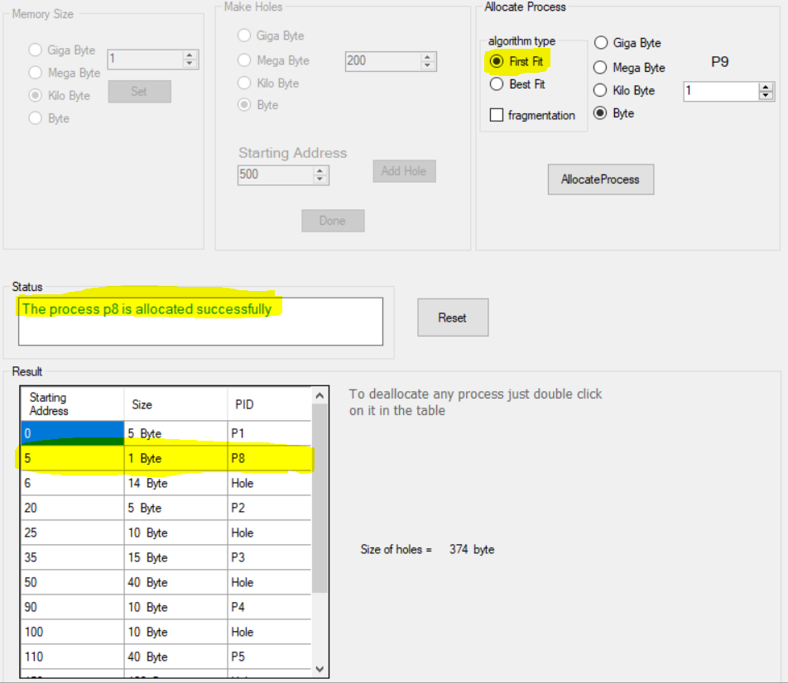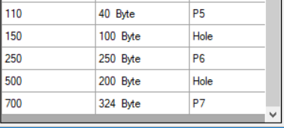

1. Deallocate P4 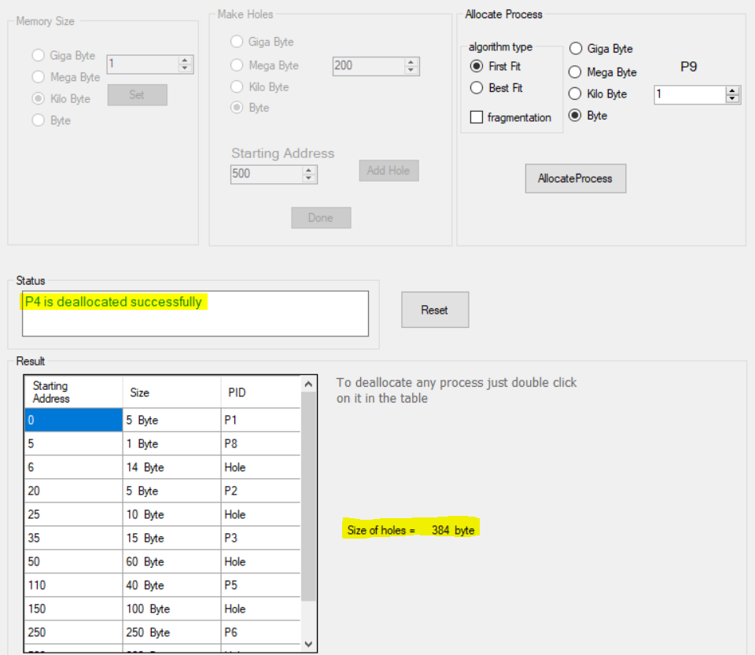

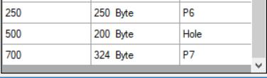

1. Allocate process P9 with size 10 byte and Best fit algorithm 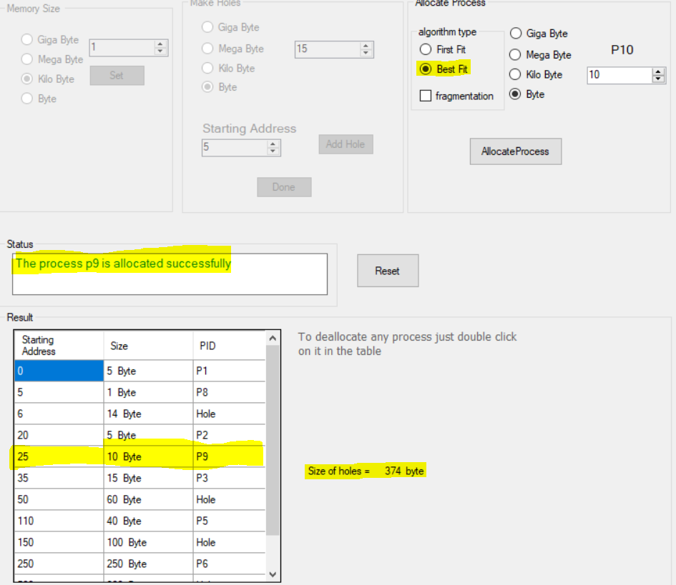

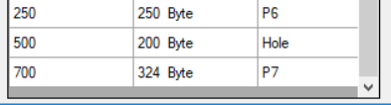

1. Allocate process P10 with size 300 byte and Best fit algorithm without fragmentation “ allocated is failed ” 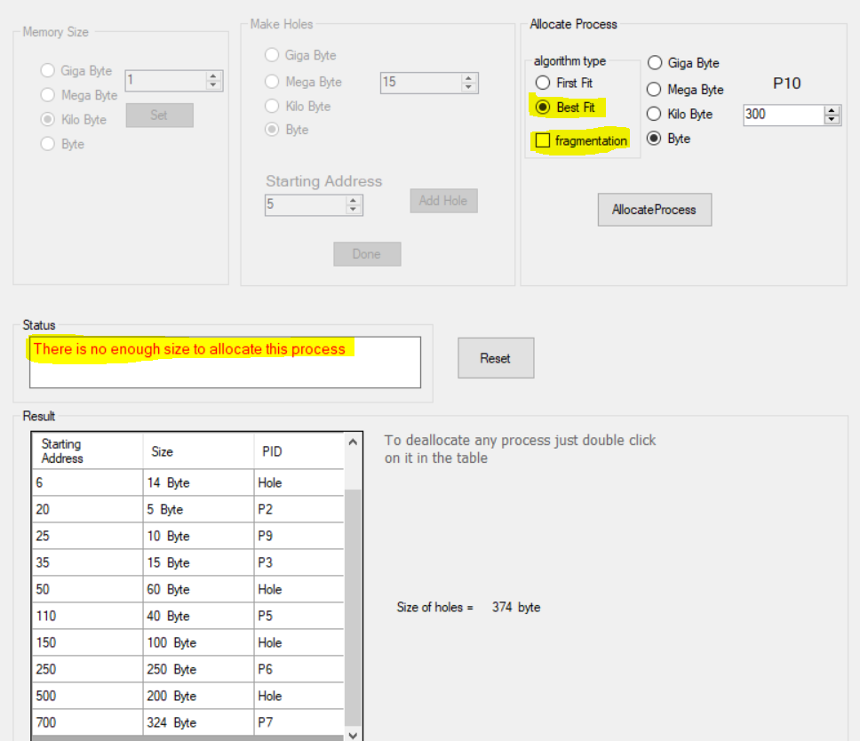
2. Allocate process P10 with size 300 byte and Best fit algorithm with fragmentation 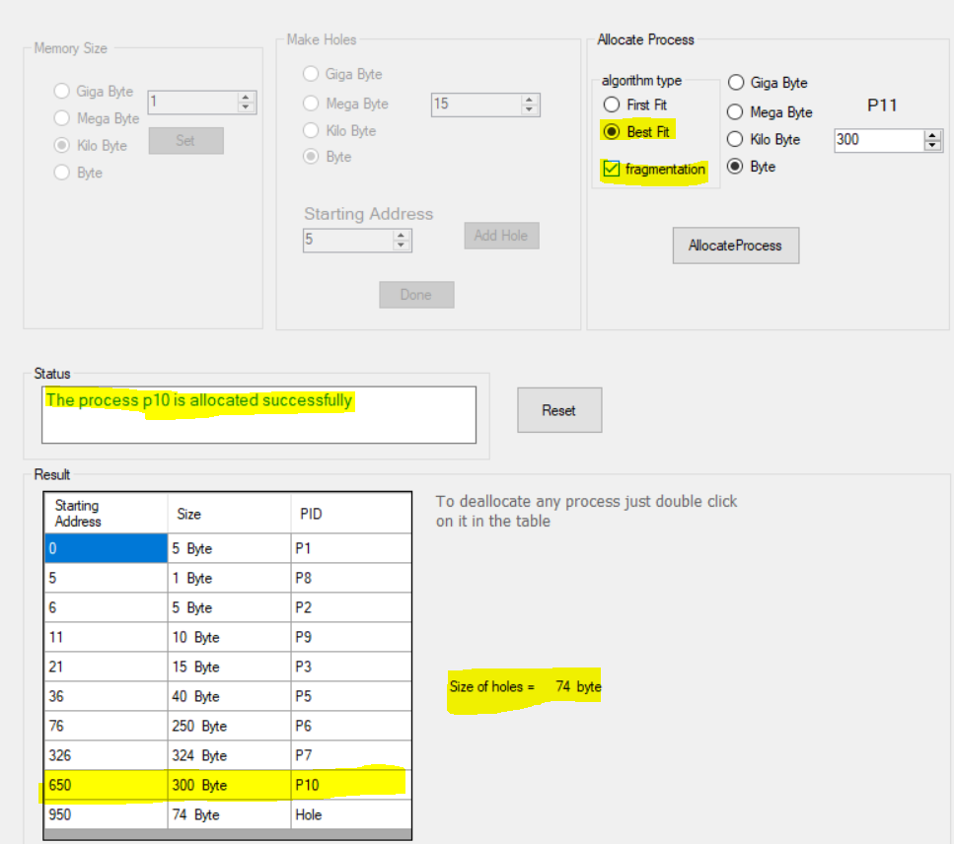
3. Allocate process P11 with size 74 byte and Best fit algorithm with fragmentation 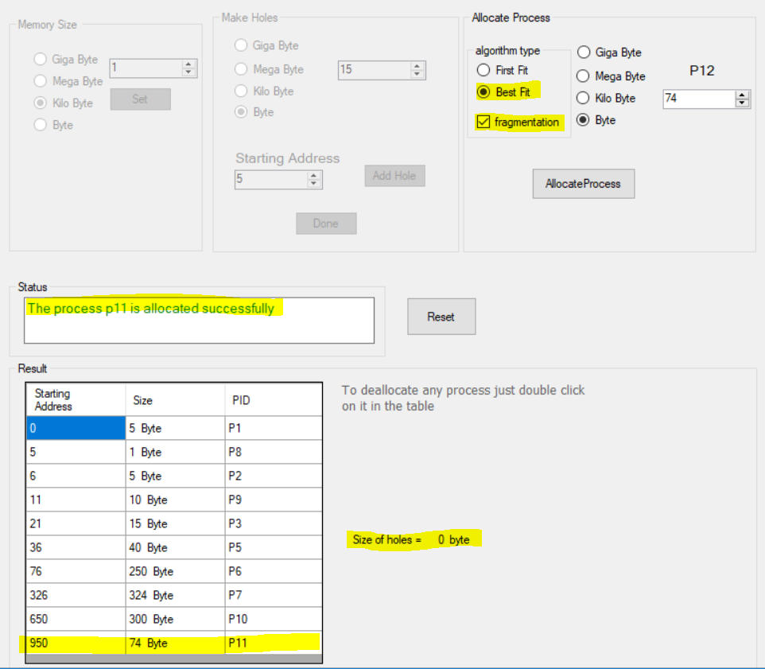
4. Allocate process P12 with size 1 byte and Best fit algorithm with fragmentation “allocated is failed” 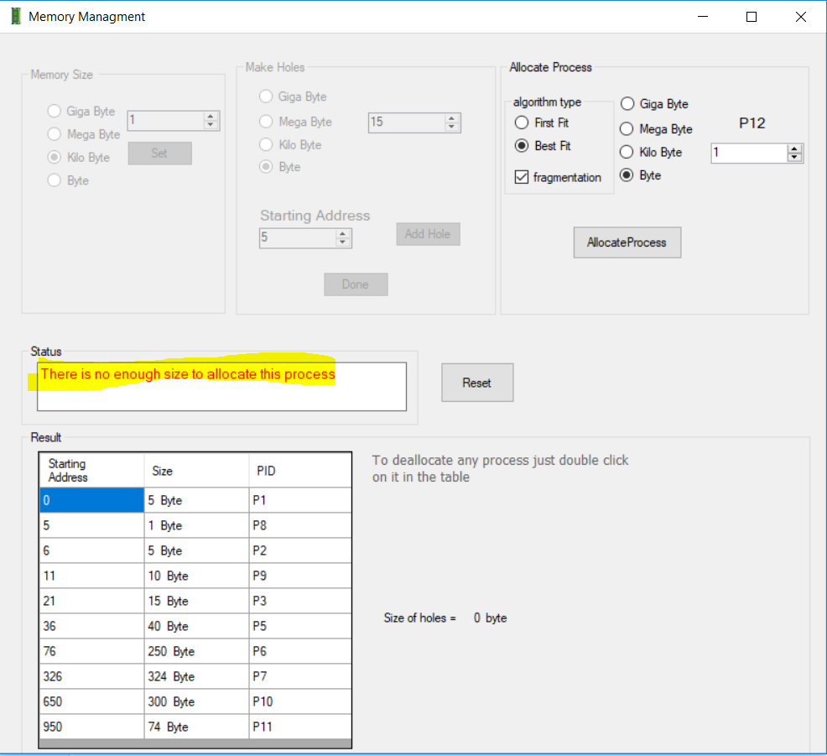
5. Deallocate P7 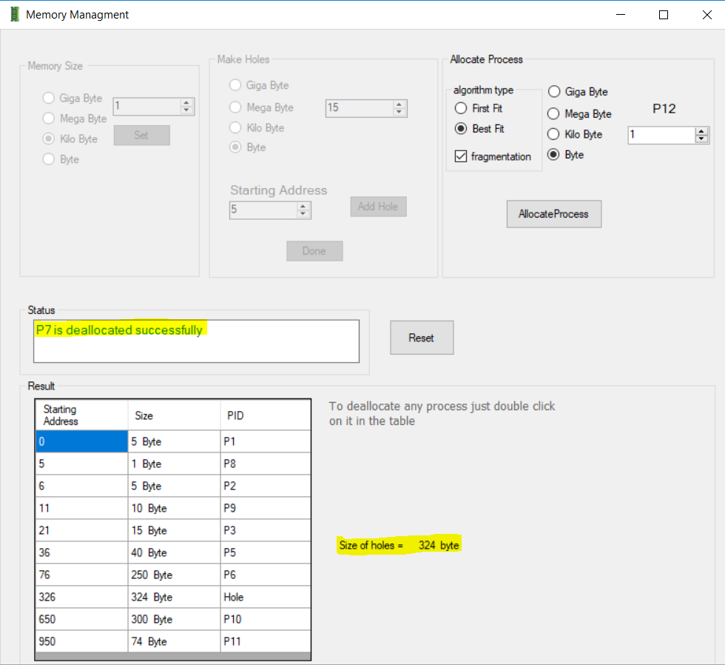
6. Allocate process P12 with size 324 byte and first fit algorithm with fragmentation 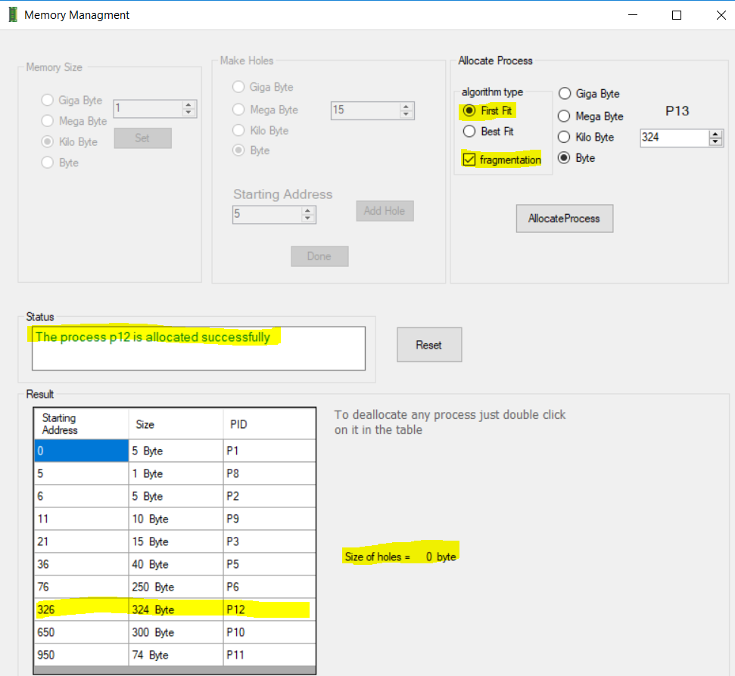
7. Deallocate all processes 